|  |
| --- |
| Functional Specification Document  Space trading unit |

**DOCUMENT VERSION <0.1>**

**July 13, 2019**

**AUTHORS**

|  |  |  |
| --- | --- | --- |
| **Name** | **Role** | **Department** |
| Do Dang | Developer |  |

**DOCUMENT HISTORY**

|  |  |  |  |
| --- | --- | --- | --- |
| **Date** | **Version** | **Document Revision Description** | **Document Author** |
|  |  |  |  |
|  |  |  |  |
|  |  |  |  |
|  |  |  |  |
|  |  |  |  |

**APPROVALS**

|  |  |  |  |
| --- | --- | --- | --- |
| **Approval Date** | **Approved Version** | **Approver Role** | **Approver** |
|  |  |  |  |
|  |  |  |  |
|  |  |  |  |
|  |  |  |  |

**Table of Contents**

1. Introduction 3

1.1 Purpose of the document 3

1.2 Project Scope 3

1.3 Related documents 3

2. System/ Solution Overview 4

2.1 Context Diagram/ Interface Diagram/ Data Flow Diagram, Application Screen Flow, Sitemap, Process Flow 4

2.2 System Actors 8

# Introduction

This document describe for Intergalactic units exchange project

## Purpose of the document

The Functional Specification Document is a document that provides detailed information on *how* the system solution will function and the requested behavior. This document is created based on the high-level requirements identified in the Business Requirements Document and provides traceability on the functional specifications back to the business requirements. Included in this document will be the detailed functional requirements including use cases, system inputs and outputs, process flows, diagrams, and mock ups.

## Project Scope

This project accept input as a query that can define mapping between galactic units with Roman numbers, or just Calculate value of it.

## 1.3 Related documents

|  |  |  |
| --- | --- | --- |
| **Component** | **Name (with link to the document)** | **Description** |
|  | C# Backend Test.docx | Solution requirements |

# System/ Solution Overview

Application let user input string query for some purpose

* Defined name of intergalactic currency units mapping with Roman number and based on Roman value calculation
* Defined name and unit rate per unit of galaxy trading items (common metals dirt (gold, iron..) )
* Calculate value of query

## Context Diagram/ Interface Diagram/ Data Flow Diagram, Application Screen Flow, Sitemap, Process Flow

* + 1. Main flow

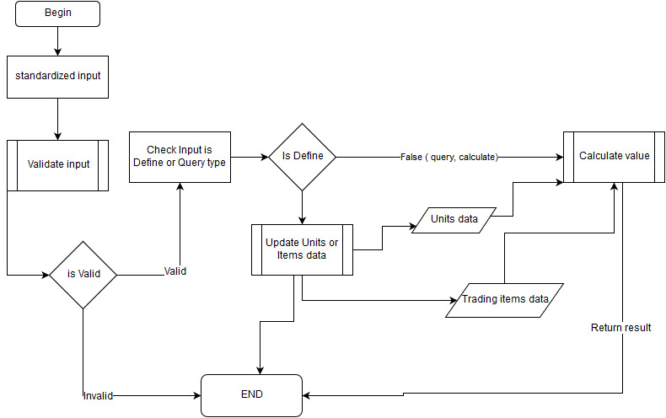

* + 1. Validate input

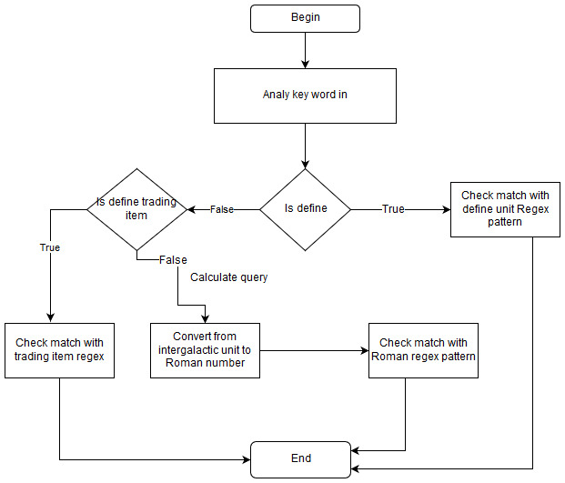

* + 1. Update exchange unit , trading item data

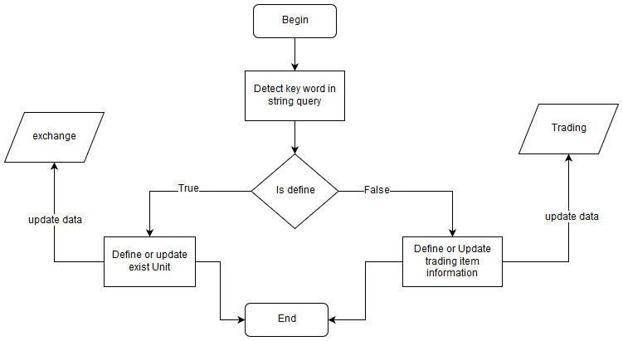

* + 1. Calculate query string

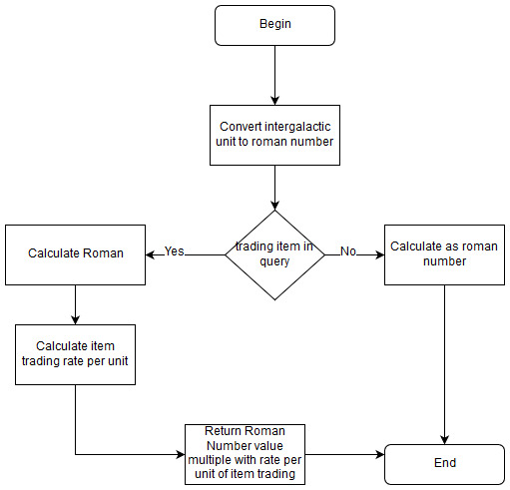

2.1.5 Screen capture

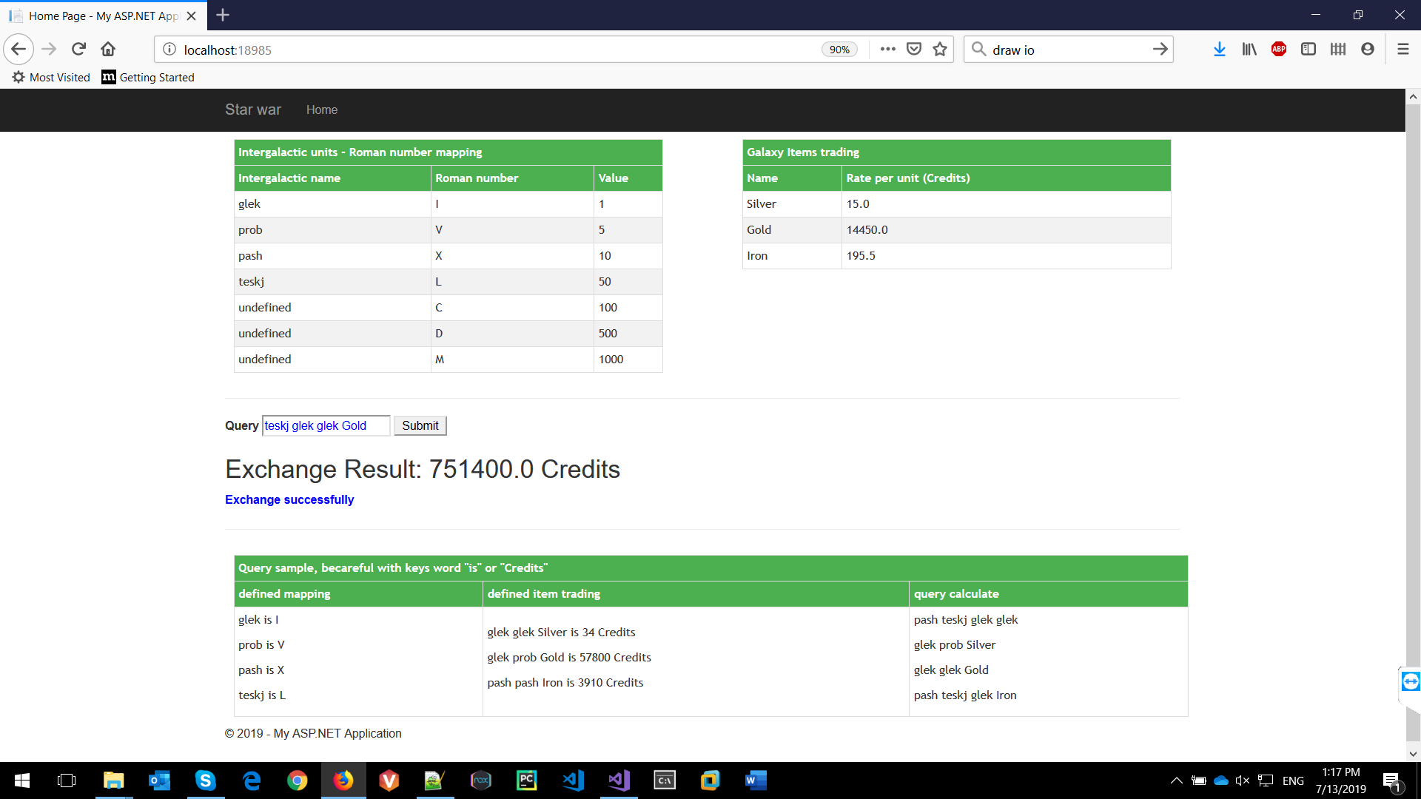

## 2.2 System Actors

### 2.2.1 User Roles and Responsibilities / Authority Requirements

|  |  |  |  |  |
| --- | --- | --- | --- | --- |
| **User/Role** | **Example** | **Frequency of Use** | **Security/Access, Features Used** | **Additional Notes** |
| *Every user* |  | Submit query |  |  |